-- testing power bi dashboards

Race Structure Evolution
-- 1 What is the total number of Tours conducted so far?
use tour_de_france ;
Go

select count(*) from Cleaned_Tours;
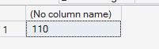
Insight: totally 110 tours happened yet from 1903 to 2023
Why : 4 +7 years cancelled due to world war 1 and 2
To do : aware of wars

— 2 How has the total stage distance changed over time?
SELECT
Year,
AVG([Distance(km)]) AS Avg_Distance_KM
FROM Cleaned_Stages
GROUP BY Year
ORDER BY Year;

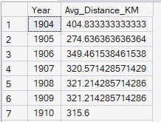
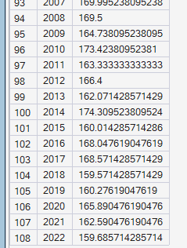

Insight: distance decreased gradually

3 How many stages are conducted on average per year?
SELECT
avg(Stages)
FROM Cleaned_Tours;

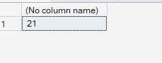
Insight: on average 21

4 What is the trend of stage types over years?
select Year,Stage_type,count(*) from Cleaned_Stages group by Year,StageType order by year;
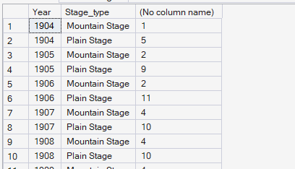
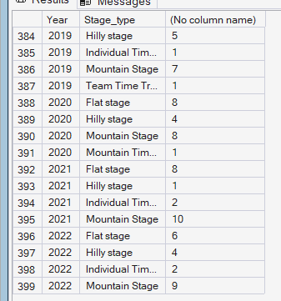

Insights:
Till 1927 only two stages left (mountain,plane)
In 1928 Team tail trail was added
Indivisual time trial was added on 1933
Plain stage ended from 2008
plain,Mountain stage has been continuing in every year
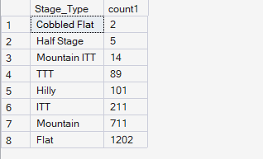
Cobbled Flat ,half Stage,Mountain Itt used very less

5 What is the longest and shortest stage ever conducted ?

SELECT *
FROM (
SELECT TOP 1
[Stage],
[Stage_type],
[Distance(km)]
FROM [Cleaned_Stages]
ORDER BY [Distance(km)] ASC

UNION ALL

SELECT TOP 1
[Stage],
[Stage_type],
[Distance(km)]
FROM [Cleaned_Stages]
ORDER BY [Distance(km)] DESC
) t;

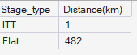

Insights:
Longest and shortest distances are 1 and 482 type IIT and Flat respectively

6 Which month hosts most stages?

select month(Start_Date),count(*) as count1 from Cleaned_Tours Group by month(Start_Date) ;

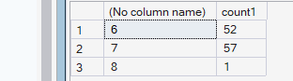
Insights: june july

Performance Evolution
1 How has average speed evolved over the years?
SELECT
[Year],
[AvgSpeed(km/h)]
FROM [Cleaned_Winners];

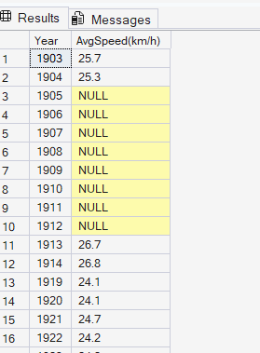
insights:average speed increased year by year (attached a tool tip for sum of stage distance in year)
Why: speed increased distance also decreased

3 Fastest and slowest winner in history.
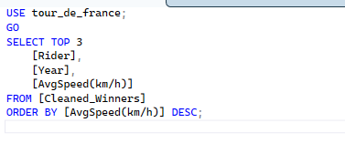
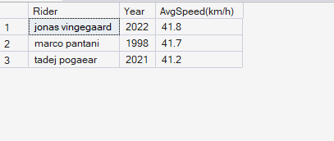
Jonas bingegaard is fastest guy with avg speed 41.8 in 2022

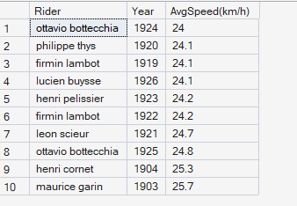
Ottavio bottecchia is slowest rider with 24 speed in 1924

4 what are the speed ranks of total wins (new)

USE tour_de_france;
GO

WITH RiderStats AS (
SELECT
Rider,
COUNT(*) AS TotalWins,
AVG(CAST([AvgSpeed(km/h)] AS FLOAT)) AS AvgSpeed
FROM Cleaned_Winners
WHERE [AvgSpeed(km/h)] IS NOT NULL
GROUP BY Rider
)

SELECT
Rider,
TotalWins,
AvgSpeed,

-- Rank by Speed (1 = Fastest)
RANK() OVER (ORDER BY AvgSpeed DESC) AS SpeedRank,

-- Rank by Wins (1 = Most Wins)
RANK() OVER (ORDER BY TotalWins DESC) AS WinsRank

FROM RiderStats
ORDER BY SpeedRank;

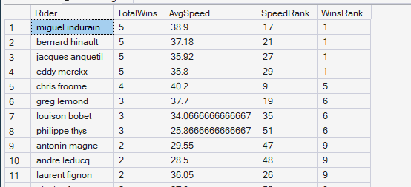
Insights: top winners have average speed rank
Why: this might be due to distance initially small so speed ranks may decreased

5 what is the completion rate over years (new)

SELECT
Year,
Starters,
Finishers,
(CAST(Finishers AS FLOAT) / NULLIF(Starters, 0)) * 100 AS CompletionRate_Percent
FROM Cleaned_Tours
ORDER BY Year;

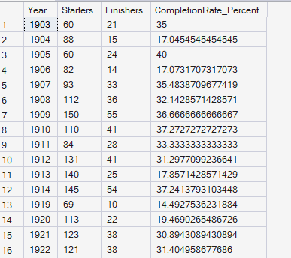
Insights : Completion rate increased year wise

Rider Profile Evolution
1 What is the average age of winners? Are they getting younger or older
(in visual when we calculate avg from age measure it is giving 28 may be due to null values in date)

Average age

SELECT
AVG(
YEAR(t.Start_Date) - YEAR(w.Born)
- CASE
WHEN FORMAT(t.Start_Date, 'MMdd') < FORMAT(w.Born, 'MMdd')
THEN 1
ELSE 0
END
) AS Average_Rider_Age
FROM Cleaned_Winners w
JOIN Cleaned_Tours t
ON w.Year = t.Year;

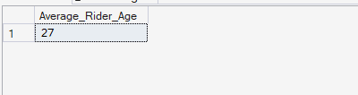
SELECT
w.Year,
w.Rider,
YEAR(t.Start_Date) - YEAR(w.Born)
- CASE
WHEN DATEADD(YEAR, DATEDIFF(YEAR, w.Born, t.Start_Date), w.Born) > t.Start_Date
THEN 1
ELSE 0
END AS Winner_Age
FROM Cleaned_Winners w
JOIN Cleaned_Tours t
ON w.Year = t.Year
ORDER BY w.Year;

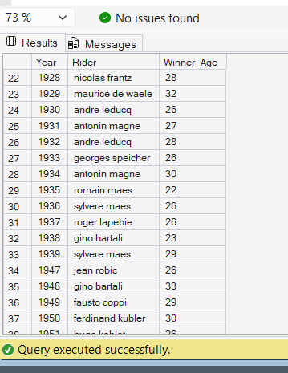

Insight : avg age of winners is 27 years
Winner age is not consisting certain pattern

2 How has winner physique (height and weight) changed over time?

USE tour_de_france;
GO

SELECT
w.Year,
AVG(w.[Height(m)]) AS Avg_Height,
AVG(w.[Weight(kg)]) AS Avg_Weight
FROM Cleaned_Winners w
GROUP BY w.Year
ORDER BY w.Year;

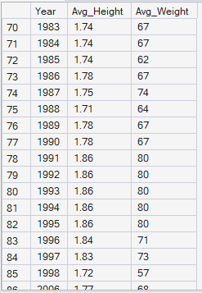

Insights: height and weight both having spikes but when we look into it height is increasing and weight getting decreasing slightly

Competitiveness Over Time
1 Which decade had the most competitive races (least time gap)?
[ we created a col decade to calculate avg of time gap as we cant calculate with decade measure ,because to calculate avg to measure visual all years of that decade is not able to calculate as not row by row calculation]

SELECT
(Year / 10) * 10 AS Decade,
AVG(Margin) AS Avg_Time_Gap
FROM Cleaned_Winners

GROUP BY (Year / 10) * 10
ORDER BY Avg_Time_Gap ASC; -- Smallest = Most Competitive

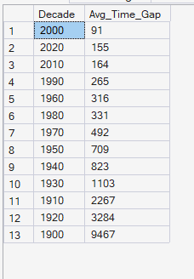
Insights: decade 2010 is highly competitive and 1900 is less competitive decade

2 Years with highest competition (lowest gaps) and biggest domination (highest gaps)
WITH DistancePerYear AS (
SELECT
Year,
SUM([Distance(km)]) AS Total_Distance
FROM Cleaned_Stages
GROUP BY Year
)

SELECT
f.Year,
d.Total_Distance,
SUM(f.TimeGap) AS TotalGap,
d.Total_Distance / SUM(f.TimeGap) AS CompetitionScore
FROM Cleaned_Finishers f
JOIN DistancePerYear d
ON f.Year = d.Year
WHERE f.Rank > 1
AND f.Rank <= 10
AND f.TimeGap IS NOT NULL
GROUP BY f.Year, d.Total_Distance
ORDER BY CompetitionScore DESC;

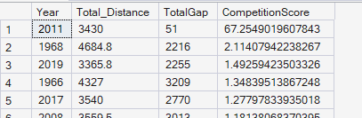
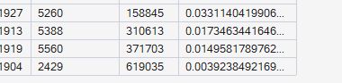
i
Inisihts: 2011 having huge competition and 1904 have less competetion

Dashboard 2: Anatomy of a Victory Core Question:
What are the key factors and strategies that lead to winning the Tour de France? The Winner's Profile
1 How many unique riders have won the Tour
SELECT COUNT(DISTINCT Rider) AS Unique_Winners
FROM Cleaned_Winners;

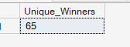
Insights:65

2 Riders who won multiple Tours
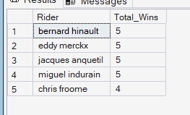
Insights: bernard hinault, eddy merckx,jacques anquetil
Miques and quetil

3 Who is the most dominant rider (speed and stages won)

SELECT TOP 5
Rider,
SUM(StagesWon) AS Total_Stage_Wins,
AVG([AvgSpeed(km/h)]) AS Average_Speed,
SUM(StagesWon) * AVG([AvgSpeed(km/h)]) AS Dominance_Score
FROM Cleaned_Winners
GROUP BY Rider
ORDER BY Dominance_Score DESC;

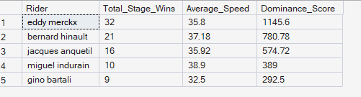
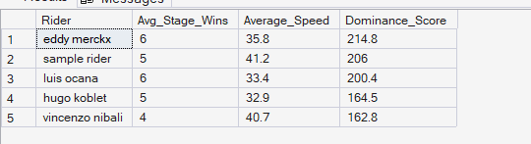
Insights : eddy merchx is a dominant rider with 6 avg stage wins and he is dominant for long years also by total stages 32

Winning Strategies
1 Riders who won with the least number of stage wins
SELECT
Rider,
SUM(StagesWon) AS Total_Stage_Wins
FROM Cleaned_Winners
GROUP BY Rider
ORDER BY Total_Stage_Wins;
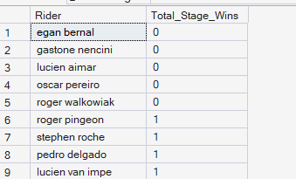
Insights: winners does not depend on winning stages , average 2 to 4 stage wins only there there are some riders with zero wins

4 who is lost many times at last won

WITH FirstWin AS (
SELECT Rider, MIN(Year) AS First_Win_Year
FROM Cleaned_Finishers
WHERE Rank = 1
GROUP BY Rider
)
SELECT
f.Rider,
COUNT(DISTINCT f.Year) AS Seasons_Before_First_Win
FROM Cleaned_Finishers f
JOIN FirstWin fw
ON f.Rider = fw.Rider
WHERE f.Year < fw.First_Win_Year
GROUP BY f.Rider
ORDER BY Seasons_Before_First_Win DESC;
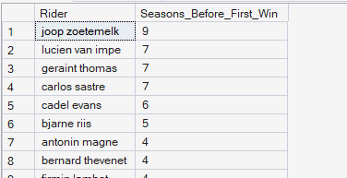

Insights : joop zoetemelk is the never give up winner

3 Most and least stages won by a winner.

SELECT
Rider,
MAX(StagesWon) AS Max_Stages,
MIN(StagesWon) AS Min_Stages
FROM Cleaned_Winners
GROUP BY Rider
ORDER BY Min_Stages ASC;

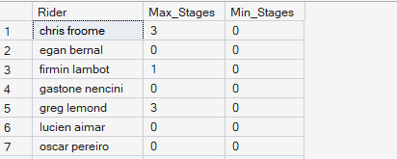

Insights:roger wolkoweak lucien and oscar didn’t won single stage entire career

5 Do mountain stages decide most Tours?

